Topic | Five kingdoms | Level | GCSE
Outcomes | - To state the main feature of each of the five Kingdoms  - To classify an unknown organism and provide justification

Kingdoms: classification and justification

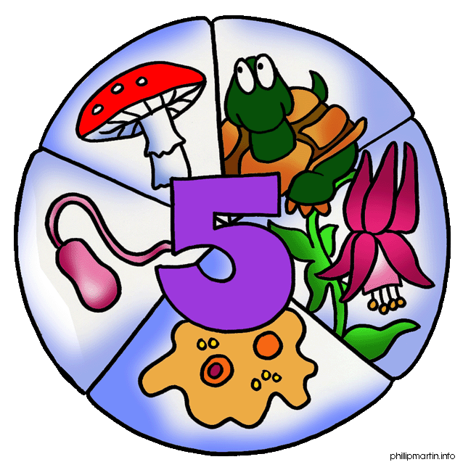

Feature | Animal | Plant | Bacteria | Fungi | Protists | Unknown organism
e.g. Creates spores | N | Y | Y | Y | N
Has chlorophyll
Has a flagellum
Multicellular
Reproduces by sexual reproduction only
Has a true nucleus
Performs respiration
Stores carbohydrates as starch
They do not have chitin cell walls
They do not feed off decaying matter
They are autotrophs
They respond to stimuli
Biologists put organisms into groups based on characteristics, or features, that they share. For example, all plants contain chlorophyll and so belong to the Plant Kingdom. You are going to be given an organism to classify. You will need to decide what Kingdom the organism belongs to.

- Before you classify your organism you will need to find out what features are unique to each Kingdom by completing the table below. Write Y if the feature is found in that Kingdom and N if it is not. If you are unsure use a ?

- Now, using your table above you are going to try and classify the unknown organism below. Complete the shaded column in the table to help you decide what Kingdom the organism belongs to. Can you justify your choice?
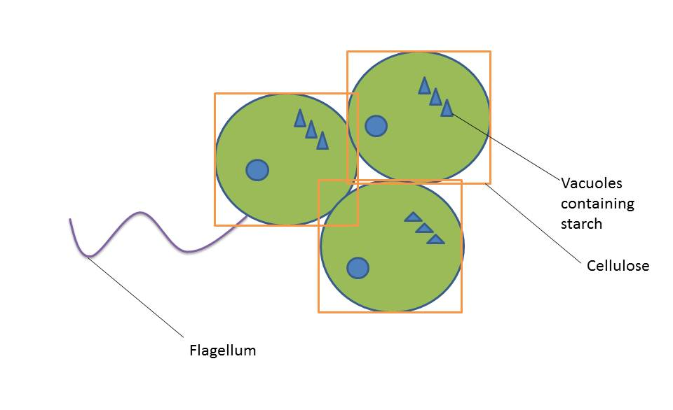
Figure 1 Unknown organism. Some key features have been annotated. You will need to work other features from the drawing

- Dr Raymond disagrees and says the organism is a bacterium. What evidence does he have to support his argument? How would you explain to him that he is wrong?

- A new organism has been discovered in Yellow Stone Park, USA. The organism has features of two Kingdoms. Draw what this organism could look like. It must have at least 4 features from each of two Kingdoms e.g. plant and fungi. Annotate each feature on your diagram stating which Kingdom each feature comes from.

- For each of the five Kingdoms, chose two defining features that you think are the most important in allowing a biologist to identify what Kingdom an organism belongs to.

Progress: further resources on classification are available here:
http://thescienceteacher.co.uk/classification/

